Abstraction in Java:
Abstraction is a process of hiding the implementation details and showing only functionality to the user.
Another way, it shows only important things to the user and hides the internal details for example sending sms, you just type the text and send the message. You don't know the internal processing about the message delivery.
Abstraction lets you focus on what the object does instead of how it does it.

Ways to achieve Abstaction:
There are two ways to achieve abstraction in java
- Abstract class (0 to 100%)
- Interface (100%)

Abstract:
An abstract class can have abstract methods which have to be implemented by its sub classes.
An abstract method does not have concrete implementation or body, and must ends with a semicolon (;)
Rules for abstract class and abstract method:
An abstract class:
  - cannot be instantiated by new keyword. The purpose of an abstract class is to be inherited by derived classes.
  - It needs to be extended and its method implemented. It cannot be instantiated.
  - If you are extending any abstract class that have abstract method, you must either provide the implementation of the method or make this class abstract.
  - Abstract classes may or may not contain abstract methods, i.e., it can have both abstract method (method without body) and non-abstract methods (method with body) .
  - But, if a class has at least one abstract method, then the class must be declared abstract.
  - To use an abstract class, you have to inherit it from another class, provide implementations to the abstract methods in it.
  - If you inherit an abstract class, you have to provide implementations to all the abstract methods in it.

An abstract method:
  - does not have body and must end with a semicolon.
  - must be implemented by concrete sub classes.
  - makes the enclosing class must be declared as abstract also
  - If there is any abstract method in a class, that class must be abstract.

(i.e..,) Abstract method without abstract class will result in compilation error
package Abstract;

class Bike{ //The type Bike must be an abstract class to define abstract methods.
abstract void run(); //The abstract method run in type Bike can only be defined by an abstract class
}

Example:
package Abstract;
abstract class Bank //Abstract class
{
Bank(){System.out.println("Constructor for abstract method");}
abstract int getRateOfInterest(); // Abstract Method
void BankList() // Non-Abstract Method
{
System.out.println("SBI & PNB");
}
}

class SBI extends Bank
{
int getRateOfInterest()
{
return 7;
}
}

class PNB extends Bank
{
int getRateOfInterest()
{
return 8;
}
}

class TestBank
{
public static void main(String args[])
{
Bank b;
b = new SBI();
b.BankList();
System.out.println("SBI interest: " + b.getRateOfInterest() + " %");
b = new PNB();
System.out.println("PNB interest: " + b.getRateOfInterest() + " %");

}
}

Output:
Constructor for abstract method
SBI & PNB
SBI interest: 7 %
Constructor for abstract method
PNB interest: 8 %

Interface:
An interface in java is a blueprint of a class. It has static constants and abstract methods.
The interface in java is a mechanism to achieve abstraction.
There can be only abstract methods in the java interface not method body.
It is used to achieve abstraction and multiple inheritance in Java.
Java Interface also represents IS-A relationship.
It cannot be instantiated just like abstract class.
Why use Java interface?
There are mainly three reasons to use interface. They are given below.
- It is used to achieve abstraction.
- By interface, we can support the functionality of multiple inheritance.
- It can be used to achieve loose coupling.

Other Features
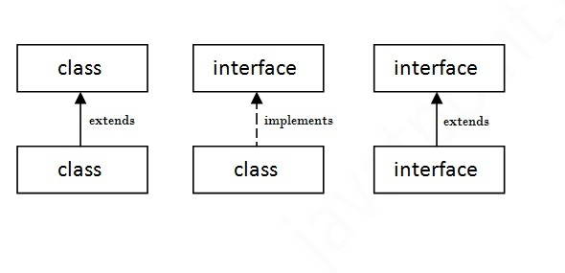
- Since Java 8, interface can have default and static methods.

- The java compiler adds public and abstract keywords before the interface method. More, it adds public, static and final keywords before data members. In other words, Interface fields are public, static and final by default, and methods are public and abstract.
Example:
package Abstract;
interface Bank1 // interface
{
float rateOfInterest(); // method without body
}

class SBI1 implements Bank1 // class implementing interface
{
public float rateOfInterest() {
return 9.15f;
}
}

class PNB1 implements Bank1 // class implementing interface
{
public float rateOfInterest() {
return 9.7f;
}
}

class TestInterface2
{
public static void main(String[] args) {
Bank1 b ;
b = new SBI1();
System.out.println("SBI: " + b.rateOfInterest());
b = new PNB1();
System.out.println("PNB: " + b.rateOfInterest());
}
}

Output:

SBI: 9.15
PNB: 9.7

Real Scenario of Abstract Class and Interface:
package Abstract;

interface A{
void a();
void b();
void c();
void d();
}

abstract class B implements A{
public void c(){System.out.println("I am C");}
}

class M extends B{
public void a(){System.out.println("I am a");}
public void b(){System.out.println("I am b");}
public void d(){System.out.println("I am d");}
}

class AbstractAndInterface{
public static void main(String args[]){
A a=new M();
a.a();
a.b();
a.c();
a.d();
}}

Output:

I am a
I am b
I am C
I am d

Why Java Doesn't Support Multiple Inheritance:
- The main problem with multiple inheritance (alluded to by Colin and Rin) is known is The Diamond Problem.
- The diamond problem is an ambiguity that arises when two classes B and C inherit from A, and class D inherits from both B and C. If a method in D calls a method defined in A (and does not override the method), and B and C have overridden that method differently, then from which class does it inherit: B, or C?
A
B C
D

- Multiple inheritance can be really difficult to understand. When you have a multiple inheritance with two classes which have methods in conflicts, how do you handle this ?
- Of course solutions exist (in C++ for example) but the creators of Java decided it was way to complicated and not really in the Java philosophy (make development a lot easier).
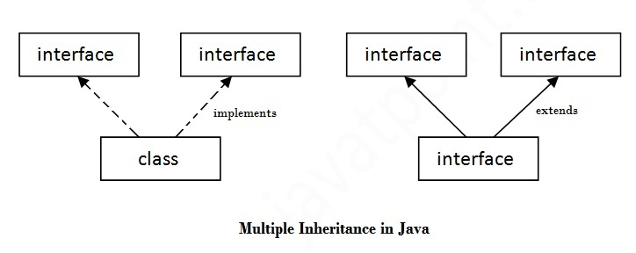
- Because interfaces specify only what the class is doing, not how it is doing it.The problem with multiple inheritance is that two classes may define different ways of doing the same thing, and the subclass can't choose which one to pick.
Multiple Inheritance in Java By Interface:
If a class implements multiple interfaces, or an interface extends multiple interfaces i.e. known as multiple inheritance.
package Interface;

public interface Printable
{
void print();
}

package Interface;

public interface Showable
{
void show();
}

package Interface;

public class MultipleInheritance implements Printable,Showable{

public static void main(String[] args)
{
MultipleInheritance mi=new MultipleInheritance();
mi.show();
mi.print();
}

public void show()
{
System.out.println("Show method implemented");
}

public void print()
{
System.out.println("Print method implemented");
}

}

Output:
Show method implemented
Print method implemented

Multiple inheritance is not supported through class in java but it is possible by interface, why?
multiple inheritance is not supported in case of class because of ambiguity. But it is supported in case of interface because there is no ambiguity as implementation is provided by the implementation class.
package Interface;

public interface Printable
{
void print();
}

package Interface;

public interface Showable
{
void print();
}

package Interface;

public class MultipleInheritance implements Printable,Showable{

public static void main(String[] args)
{
MultipleInheritance mi=new MultipleInheritance();
mi.print();
}

public void print()
{
System.out.println("Print method implemented");
}

}

As you can see in the above example, Printable and Showable interface have same methods but its implementation is provided by class TestTnterface1, so there is no ambiguity.

Interface inheritance
package Interface;

public interface Printable
{
void print();
}

package Interface;

public interface Showable extends Printable
{
void show();
}

package Interface;

public class MultipleInheritance implements Showable{

public static void main(String[] args)
{
MultipleInheritance mi=new MultipleInheritance();
mi.show();
mi.print();
}

public void show()
{
System.out.println("Show method implemented");
}

public void print()
{
System.out.println("Print method implemented");
}

}

Here in the above example, eventhough Printable interface is not implemented by class, the method print() will be implemented in class , because Showable interface inherits Printable interface. As if showable's method is implemented by class, Showable inherited interface printable's method also should be implemented.

Java 8 Default Method in Interface:
Since Java 8, we can have method body in interface. But we need to make it default method.
package Interface;

public interface Printable
{
void print();
default void msg(){System.out.println("default method");}
}

package Interface;

public class MultipleInheritance implements Printable{

public static void main(String[] args)
{
MultipleInheritance mi=new MultipleInheritance();
mi.print();
mi.msg();
}

public void print()
{
System.out.println("Print method implemented");
}

}

Output:
Print method implemented
default method

Java 8 Static Method in Interface
Since Java 8, we can have static method in interface. So that we can call the static method implemented in interface using interface name.

package Interface;

public interface Printable
{
void print();
static int cube(int x){return x*x*x;}
}

package Interface;

public class MultipleInheritance implements Printable{

public static void main(String[] args)
{
MultipleInheritance mi=new MultipleInheritance();
mi.print();
System.out.println(Printable.cube(3));
}

public void print()
{
System.out.println("Print method implemented");
}

}
Output:
Print method implemented
9

What is marker or tagged interface?
Marker interface in Java is interfaces with no field or methods. In simple words, empty interface in java is called marker interface.
Example of marker interface is Serializable, Cloneable and Remote interface.
These are used to indicate something to compiler or JVM. So if JVM sees a Class implements marker interface, it performs some special operation on it, similar way if JVM sees one Class is implement Cloneable it performs some operation to support cloning.
Same is true for RMI and Remote interface. So in short, Marker interface is to indicate or signal or command to Compiler or JVM.
An interface that have no member is known as marker or tagged interface. For example: Serializable, Cloneable, Remote etc.
They are used to provide some essential information to the JVM so that JVM may perform some useful operation.
Public interface Serializable
{
}

Difference between abstract class and interface
Abstract class and interface both are used to achieve abstraction where we can declare the abstract methods. Abstract class and interface both can't be instantiated.
But there are many differences between abstract class and interface that are given below.

Abstract Class | Interface
Abstract class can have abstract and non-abstract methods. | Interface can have only abstract methods. Since Java 8, it can have default and static methods also.
Abstract class doesn't support multiple inheritance. | Interface supports multiple inheritance.
Abstract class can have final, non-final, static and non-static variables. | Interface has only static and final variables.
Abstract class can provide the implementation of interface. | Interface can't provide the implementation of abstract class.
The abstract keyword is used to declare abstract class. | The interface keyword is used to declare interface.
Example:  public abstract class Shape{  public abstract void draw();  } | Example:  public interface Drawable{  void draw();  }

Simply, abstract class achieves partial abstraction (0 to 100%) whereas interface achieves fully abstraction (100%).

Example of abstract class and interface in Java
Let's see a simple example where we are using interface and abstract class both.

//Creating interface that has 4 methods
interface A{
void a();//bydefault, public and abstract
void b();
void c();
void d();
}

//Creating abstract class that provides the implementation of one method of A interface
abstract class B implements A{
public void c(){System.out.println("I am C");}
}

//Creating subclass of abstract class, now we need to provide the implementation of rest of the methods
class M extends B{
public void a(){System.out.println("I am a");}
public void b(){System.out.println("I am b");}
public void d(){System.out.println("I am d");}
}

//Creating a test class that calls the methods of A interface
class Test5{
public static void main(String args[]){
A a=new M();
a.a();
a.b();
a.c();
a.d();
}}

Output:

I am a
I am b
I am c
I am d

